Smart Ceiling Lights

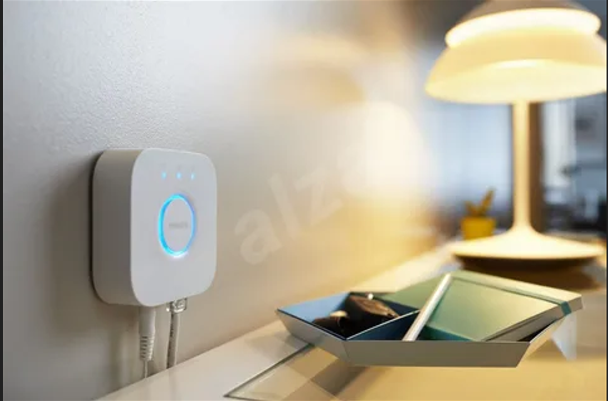

#### ****Description:****

**Smart Ceiling Lights** are modern, energy-efficient lighting solutions designed to seamlessly integrate with your smart home ecosystem. These lights offer customizable brightness, color options, and advanced features like voice control and scheduling. Perfect for any room in your home, Smart Ceiling Lights provide both functionality and style.

* **Technology:** Wi-Fi, Bluetooth, or Zigbee (depending on the model).
* **Compatibility:** Works with iOS and Android devices.
* **Bulb Type:** Integrated LED (non-replaceable).
* **Wattage:** 20W (equivalent to 100W incandescent).
* **Lumens:** 1600 lumens.
* **Color Options:** Adjustable white light (2200K-6500K) + 16 million colors (for RGB models).
* **Dimmable:** Yes.
* **Lifespan:** 50,000 hours.
* **Energy Efficiency:** Energy Star certified.
* **Control Options:** Mobile app, voice control (Alexa, Google Assistant, Apple HomeKit).

#### ****Key Features:****

* **Customizable Lighting:** Adjust brightness and color to create the perfect ambiance.
* **Voice Control:** Compatible with Alexa, Google Assistant, and Apple HomeKit for hands-free control.
* **Energy-Efficient:** Uses up to 85% less energy than traditional incandescent bulbs.
* **Scheduling and Automation:** Set schedules, timers, and routines for automated lighting control.
* **Group Control:** Control multiple lights simultaneously for synchronized lighting.
* **Easy Installation:** Designed for simple ceiling mounting with included hardware.
* **Modern Design:** Sleek and stylish, suitable for any home decor.

#### ****Pricing:****

* **Single Light:** $79.99
* **2-Pack:** 139.99(139.99(70.00 per light)
* **4-Pack:** 259.99(259.99(65.00 per light)

#### ****Where to Use:****

* **Living Rooms:** Create a cozy or vibrant atmosphere with customizable colors.
* **Bedrooms:** Set the perfect lighting for relaxation or wake-up routines.
* **Kitchens:** Brighten up workspaces with adjustable white light.
* **Home Offices:** Enhance productivity with focused lighting.
* **Hallways:** Provide consistent and energy-efficient lighting.

### ****Customer Reviews:****

* ⭐⭐⭐⭐⭐ "These Smart Ceiling Lights are amazing! They were super easy to install, and I love controlling them with my phone. The colors are so vibrant!" – Sarah L.
* ⭐⭐⭐⭐ "Great value for the price. The lights are bright, and the app is easy to use. Highly recommend for anyone looking to upgrade their smart home lighting." – James T.
* ⭐⭐⭐⭐⭐ "I love how energy-efficient these lights are. The scheduling feature is a game-changer for my daily routine." – Emily R.

### ****How to Order:****

1. Visit our website: [www.brightworldlighting.com](http://www.brightworldlighting.com/)
2. Select your preferred pack size (Single, 2-Pack, or 4-Pack).
3. Add to cart and proceed to checkout.
4. Enjoy free shipping on all orders over $100!

### ****Warranty and Support:****

* **Warranty:** 2-year limited warranty covering manufacturing defects.
* **Customer Support:** Contact us at [support@brightworldlighting.com](mailto:support@brightworldlighting.com) or call +1-800-123-4567 for assistance.

### ****Visual Representation:****

Include high-quality images of the Smart Ceiling Lights in different settings (e.g., living room, bedroom) to showcase their versatility and design.